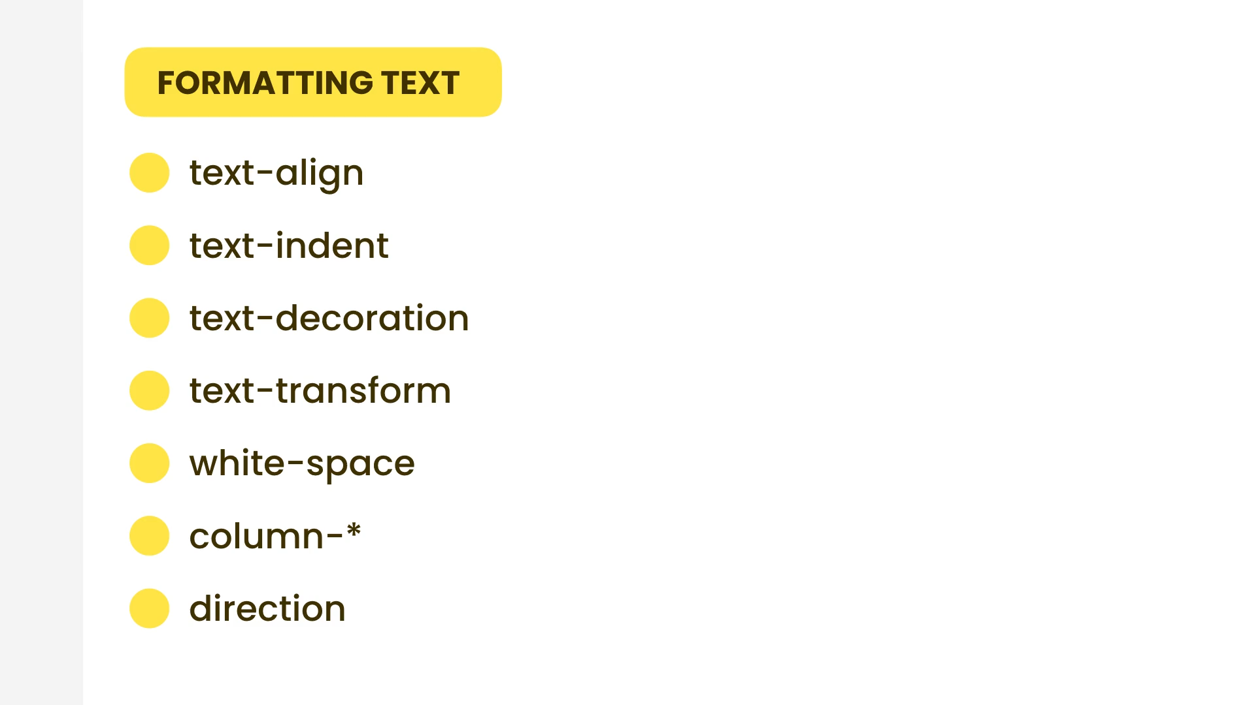

|  |  |
| --- | --- |
| Class | Properties |
| text-left | text-align: left; |
| text-center | text-align: center; |
| text-right | text-align: right; |
| text-justify | text-align: justify; |
| text-start | text-align: start; |
| text-end | text-align: end; |